**Sample RCCUY Paper for A4 Page Size**

First Author[1], Second Author[2] & Third Author[3]

Abstract

This document gives formatting instructions for authors preparing papers for publication in the Proceedings of an RCCUY conference. The authors must follow the instructions given in the document for the papers to be published. You can use this document as both an instruction set and as a template into which you can type your own text. This document gives formatting instructions for authors preparing papers for publication in the Proceedings of an RCCUY conference. The authors must follow the instructions given in the document for the papers to be published. You can use this document as both an instruction set and as a template into which you can type your own text.

Keywords - Include at least 5, not more than 6 keywords

Introduction

This document is a template. An electronic copy can be downloaded from the conference website. For questions on paper guidelines, please contact the conference publication committee as indicated on the conference website. Information about final paper submission is available on the conference website.

Page Layout

An easy way to comply with the conference paper formatting requirements is to use this document as a template and simply type your text into it.

Page Layout

Your paper must use a page size corresponding to A4 which is 210 mm (8.27") wide and 297 mm (11.69") long. The margins must be set as follows:

* Top = 1"
* Bottom = 1"
* Left =1.2"
* Right = 0.7"

Page Style

All paragraphs must be indented. All paragraphs must be justified, i.e. both left-justified and right-justified.

Text Font of Entire Document

The entire document should be in Times New Roman font. Type 3 fonts must not be used. Other font types may be used if needed for special purposes.

Recommended font sizes are shown in Table 1.

Title and Author Details

Title must be in 14 pt Regular font. Author name must be in 12 pt Regular font. Author designation, university and email address will be in footnote, 10 pt.

All title and author details must be in single-column format and must be cantered.

Every word in a title must be capitalized except for short minor words such as “a”, “an”, “and”, “as”, “at”, “by”, “for”, “from”, “if”, “in”, “into”, “on”, “or”, “of”, “the”, “to”, “with”.

Table 1. Recommended font sizes for different items

|  |  |  |  |
| --- | --- | --- | --- |
| Font Size | Appearance (in Time New Roman) | | |
| Regular | Bold | Italic |
| 12 | table caption (capitalize each word), centre | No bold | No italic |
| 12 | figure caption(capitalize each word), centre | No bold | No italic |
| 10 | author affiliation  author email address,  abstract body | No bold | No italic |
| 12 | abstract heading  cell in a table | No bold | No italic |
| 12 | level-1 heading  level-2 heading  level-3 heading  (All in Sentence case) | No bold | No italic |
| 12 | author name (centre) |  |  |
| 14 | Research title | title bold |  |
| 12 | Main paragraph title (all Cap) | No bold | No italic |

Author details must not show any professional title (e.g. Managing Director), or any membership of any professional.

To avoid confusion, the family name must be written as the last part of each author name (e.g. John A.K. Smith).

Each affiliation must include, at the very least, the name of the company and the name of the country where the author is based (e.g. Causal Productions Pty Ltd, Australia).

Email address is compulsory for the corresponding author. If there are two authors, use 1st Author1 & 2nd Author2.

Section Headings

No more than 3 levels of headings should be used. All headings must be in 12 pt font.

* Level-1 Heading:
  + Level-2 Heading:
    - Level-3 Heading:

level-3 heading must be indented.

Figures and Tables

Figures and tables must be centred in the page. Graphics may be full colour. All colours will be retained on the CDROM. Graphics must not use stipple fill patterns because they may not be reproduced properly. Please use only *SOLID FILL*colours which contrast well both on screen and on a black-and-white hardcopy, as shown in Figure 1.



Flow rate (m3/s)

Port width to spool stroke ratio, *xv/d* (-)

Figure . A sample line graph using colours which contrast well both on screen and on a black-and-white hardcopy

Figure. 2 shows an example of a low-resolution image which would not be acceptable, whereas Figure. 3 shows an example of an image with adequate resolution. Check that the resolution is adequate to reveal the important detail in the figure.

Please check all figures in your paper both on screen and on a black-and-white hardcopy. When you check your paper on a black-and-white hardcopy, please ensure that:

* the colours used in each figure contrast well,
* the image used in each figure is clear,
* all text labels in each figure are legible.

Figure Captions

Figures must be numbered using Arabic numerals. Figure captions must be in 12pt Regular font. Captions of a single line (e.g. Figure. 2) must be centred whereas multi-line captions must be justified (e.g. Figure. 1). Captions with figure numbers must be placed after their associated figures, as shown in Figure. 1.

Table Captions

Tables must be numbered using sentence case. Table captions must be centred and in 12 pt Regular font with capitalized each word. Every word in a table caption must be capitalized except for short minor words. Captions with table numbers must be placed before their associated tables, as shown in Table 1.

Page Numbers, Headers and Footers

Page numbers must be used; headers and footers must not be used.

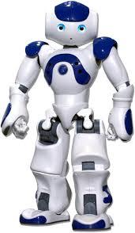

Figure . Example of an unacceptable low-resolution image

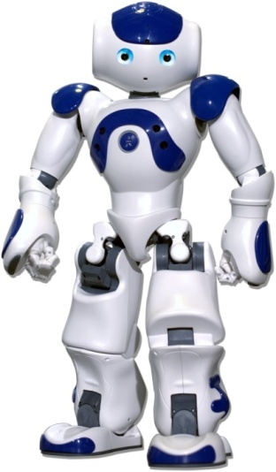

Figure . Example of an image with acceptable resolution

Links and Bookmarks

All hypertext links and section bookmarks will be removed from papers during the processing of papers for publication. If you need to refer to an Internet email address or URL in your paper, you must type out the address or URL fully in Regular font.

REFERENCES

The heading of the References section must not be numbered. All reference items must be in 12 pt font. Please use Regular and Italic styles to distinguish different fields as shown in the References section.

Conclusions

This template is for paper submission of the RCCUY2020 only. Author(s) should submit full papers electronically in doc, docx and PDF format. **Each paper is limited to 8 pages only and the submitted papers have to follow the formatting instruction**. The selected papers will be published in the conference proceedings.

The author should also send one digital copy of the camera-ready full final manuscript. The paper in the digital format may be prepared either in MS Word (.doc or .docx) format or in Acrobat PDF (.pdf) format. Please do not send other file types. Please do not send to email.

Acknowledgment

The heading of the Acknowledgment section and the References section must not be numbered. Authors acknowledge the contributors of this paper.

References

Amr E. M.et al., *Hybrid Face Detection System using Combination of Viola - Jones Method and Skin Detection,* International Journal of Computer Applications (0975 – 8887) Volume 71– No.6, May 2013

Konar et al, *Artificial Intelligence and Soft Computing Behavioral and Cognitive Modeling of the Human Brain,* Department of Electronics and Tele-communication Engineering, Jadavpur University, Calcutta, India, ISBN 0-8493-1385-6 ,2000

Ofualagba G. et al., *Automated Student Attendance Management System Using Face Recognition,*<https://www.researchgate.net/publication/327671423>, September 2018

Pramod K. P. et al, *Image Processing using Principle Component Analysis,* International Journal of Computer Applications (0975 – 8887), Volume 15– No.4, February 2011

Note:

You need to register and please send in your digital copy of the paper by

<https://cmt3.research.microsoft.com/>

The instruction can be downloaded on

<https://www.uy.edu.mm/events/call-for-papers-2/>

1. 1st Author Name, Dr, Professor, Department, University, email address
2. 2nd Author Name, Dr, Professor, Department, University, email address
3. 3rd Author Name, Dr, Associate Professor, Department, University, email address